Treasure chest of historic writing
OCTOBER 6, 2011 · NO COMMENTS
ARTS, NEWS · TAGGED: AUSTRALIA, AUTHOR, BIBLIOGRAPHY, BOOK, DANNY GOCS, DR SERGE LIBERMAN, JEWISH, JUDAICA, REFERENCE
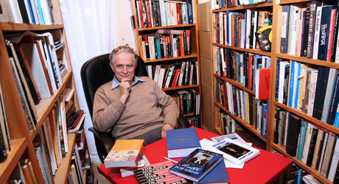
BOOKS have always been part of Melbourne author and doctor Serge Liberman’s life, so it was natural that he would be asked to research and compile The Bibliography of Australian Judaica when it was proposed in the early 1980s.
Dr Liberman took up the challenge of creating an exhaustive guide to Australian Jewry’s creative output and worked on the project – on and off – for eight years.
Little did he realise it would become part of his life for more than three decades, with an expanded third edition, The Bibliography of Australasian Judaica, set to be launched later this month. The 836-page guide has been published by Hybrid Publishers.
“It’s a book for scholars and lay people, genealogists and historians. In fact, anybody interested in researching any aspect of Australian Jewish life and history of the past 220 years,” said Dr Liberman, who has been the compiler and researcher for each edition.
“I looked at everything that was published – books, pamphlets, scholarly journals, fiction, poetry, plays – that pertains to Jews in Australia and New Zealand.
“It was not my role to give value judgment, but to record what has been done so that future generations have a source to go back to.”
The seeds for The Bibliography of Australian Judaica were sown in the late 1970s when a Jew living in France approached Sydney-based writer and editor Nancy Keesing seeking information about Yiddish poetry in Australia.
“Nancy passed on the inquiry to me and remarked that someone should write a reference book on it. I thought it was a good idea and started collating a list of Jewish works,” recalled Dr Liberman.
With financial support from Keesing, the project came to fruition in 1987 when 200 copies of The Bibliography of Australian Judaica were published.
A second edition was published in 1991, also compiled and researched by Dr Liberman.
Unfortunately, all the data for the first edition that was stored on a mainframe computer at the Fisher Library at the University of Sydney was unknowingly deleted and had to be re-keyed, along with new material. This time, 1000 copies were printed, thanks to financial support from the Mandelbaum Trust.
About three years ago Dr Liberman was approached to work on a third edition of the book, expanded to include new categories and material from New Zealand. “The first edition just had titles of works without commentaries, but for this edition I’ve included annotations and more detailed information for the reader,” he said.
Although busy during the day at his medical practice, Dr Liberman would spend nights and weekends at libraries and in his study, which houses thousands of books. His research included areas such as Jewish literature, arts and politics.
“For two years I had to put a stop to my own writing for this project.”
Dr Liberman was born in Fergana in the former Soviet Union in 1942, and came to Australia via a German displaced persons’ camp and Paris in 1951.
He has written six books of stories dealing with new migrants in Australian society – the first being On Firmer Shores, published in 1981.
He was editor of the Melbourne Chronicle from 1977-84 and was The AJN’s literary editor from 1988-99.
While acknowledging that three bibliography editions have been a labour of love, he says the next edition will be done by someone else.
“It will only get bigger in coming years with new authors and categories,” he said.
The Bibliography of Australasian Judaica is published by Hybrid Publishers. $55 (rrp)
REPORT by Danny Gocs PHOTO of Dr Serge Liberman at his Melbourne home by Peter Haskin

